Abstract Template for SSJ Fall Meeting
#Taro Zisin, Hanako Zisin (X Univ.), Jiro Zisin (MRI)

The title should be no longer than 120 characters including spaces. In the case of two or more authors, please separate them with ','. Please write '#' before the speaker's name. Author affiliations should be abbreviated as short as possible.
Abstract written in English optionally with figures/tables. Abstract written in English optionally with figures/tables. Abstract written in English optionally with figures/tables. Abstract written in English optionally with figures/tables. Abstract written in English optionally with figures/tables. Abstract written in English optionally with figures/tables. Abstract written in English optionally with figures/tables. Abstract written in English optionally with figures/tables. Abstract written in English optionally with figures/tables. Abstract written in English optionally with figures/tables. Abstract written in English optionally with figures/tables. Abstract written in English optionally with figures/tables. Abstract written in English optionally with figures/tables. Abstract written in English optionally with figures/tables. Abstract written in English optionally with figures/tables. Abstract written in English optionally with figures/tables. Abstract written in English optionally with figures/tables. Abstract written in English optionally with figures/tables. Abstract written in English optionally with figures/tables. Abstract written in English optionally with figures/tables. Abstract written in English optionally with figures/tables. Abstract written in English optionally with figures/tables. Abstract written in English optionally with figures/tables. Abstract written in English optionally with figures/tables. Abstract written in English optionally with figures/tables. Abstract written in English optionally with figures/tables. Abstract written in English optionally with figures/tables. Abstract written in English optionally with figures/tables. Abstract written in English optionally with figures/tables. Abstract written in English optionally with figures/tables. Abstract written in English optionally with figures/tables. Abstract written in English optionally with figures/tables. Abstract written in English optionally with figures/tables. Abstract written in English optionally with figures/tables. Abstract written in English optionally with figures/tables. Abstract written in English optionally with figures/tables. Abstract written in English optionally with figures/tables.
Page size and orientation = A4, Landscape, Font size ≥ 10 pt
Electronic file format = PDF, File size ≤ 1 MB, 1 page only
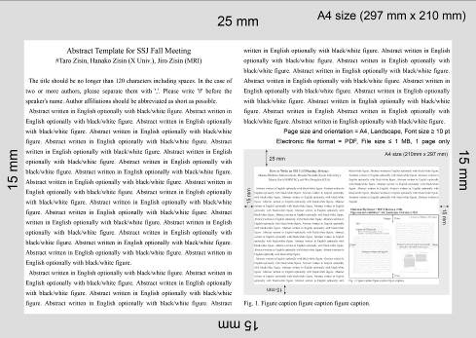
Figure/Table 1. Figure/Table caption.

